

**University of Edinburgh**

**School of Geosciences**

Evaluating Forest cover change in red panda (*Ailurus Fulgens*) habitat from 2000 – 2018

*By*

Cameron Cosgrove

In partial fulfilment of the requirement for the

Degree of BSc with Honours in Ecological and Environmental Science

April 2019

# Abstract

Habitat loss has consistently been identified as the largest threat facing the endangered red panda. Low dispersal capabilities, arboreal lifestyle, and narrow distribution also make red pandas particularly susceptible to reproductive isolation cause by habitat fragmentation. For the first time, this dissertation quantifies the extent of forest loss across the red pandas entire range, and maps the areas of low and high habitat disturbance. My results show that 1.3% of forest habitat has been lost since 2000 - 2018. The XXX area and the YYY area show the most pronounced forest loss. No countries show a net increase in forest from 2000 - 2012 in red panda habitat. Protected areas have loss less forest than non protected areas. Habitats at lower elevation show the highest amount of habitat loss, which correlates with higher human population. The forest network in red panda habitat is likely fragmented into 3 isolated populations, with X habitat bottlenecks experiencing moderate to high disturbance. The conservation implications of this work are…

Table of Contents

Abstract 2

Table of Contents 3

Acknowledgements 5

List of abbreviations 6

1. Introduction 7

The red panda 7

Ecology 7

Red panda conservaiton 9

1.3 Project Rationale 9

A remote sensing approach 10

1.4 Research questions and hypotheses 10

What change has occurred to forests in red panda habitat? 11

Where has forest been lost in red panda habitat? 11

2. Methods 11

2.1 Defining the study area 12

2.2 Data collection 12

Global Forest Change Dataset 12

Red Panda distrubution 12

2.3 Data processing 12

Forest Change 12

Hot spot identification 12

2.4 Data analysis 12

3. Results 12

3.1 What change has occurred to forests in red panda habitat? 13

3.2 Where has forest been lost in red panda habitat? 14

14

4. Discussion (Demonstrate Understanding!) 15

Key findings 15

4.1 How is Red Panda Habitat changing? 15

4.2 Conservation implications 15

4.3 Limitations 15

What needs to be considered when interpreting my results? 15

4.4 Future work 15

5. Conclusion 16

6. References 16

7. Appendices 16

Acknowledgements

I would firstly like to thank Dr Isla Myers-Smith who encouraged me to create a project I was super stoked about. Without the support of Dr Myers-Smith and her lab group, Team Shrub, I would never have had the confidence to create my own research project.

While I haven’t worked directly with them, I would like to thank the red panda network too for turning mu onto red panda conservation issues.

Izzy Rich is my hero ☺

List of abbreviations

GEE – The google earth engine

MaxEnt – Maximum entropy distribution model

IUCN

CITIES

GFC – Global forest change dataset

RQ1

RQ2

1. Introduction

Terrestrial mammal populations are changing rapidly around the world with human activity such as hunting and ecosystem modification driving these changes. SOME DATA FROM A STUDY WOULD BE NICE HERE. Such changes create a number of ethical, practical, and aesthetic concerns – such as… (examples). Much attention is given to reversing these changes and finding evidence-based solutions for mammal conservation, particularly for preventing species extinction. Data is needed to make informed conservation decisions, but is often unavailable due to the remoteness or extensive size of field sites. Remote sensing tools such as satellite imagery are increasing being employed to measure and monitor relevant ecosystem variables, can greatly enhance mammal conservation efforts.

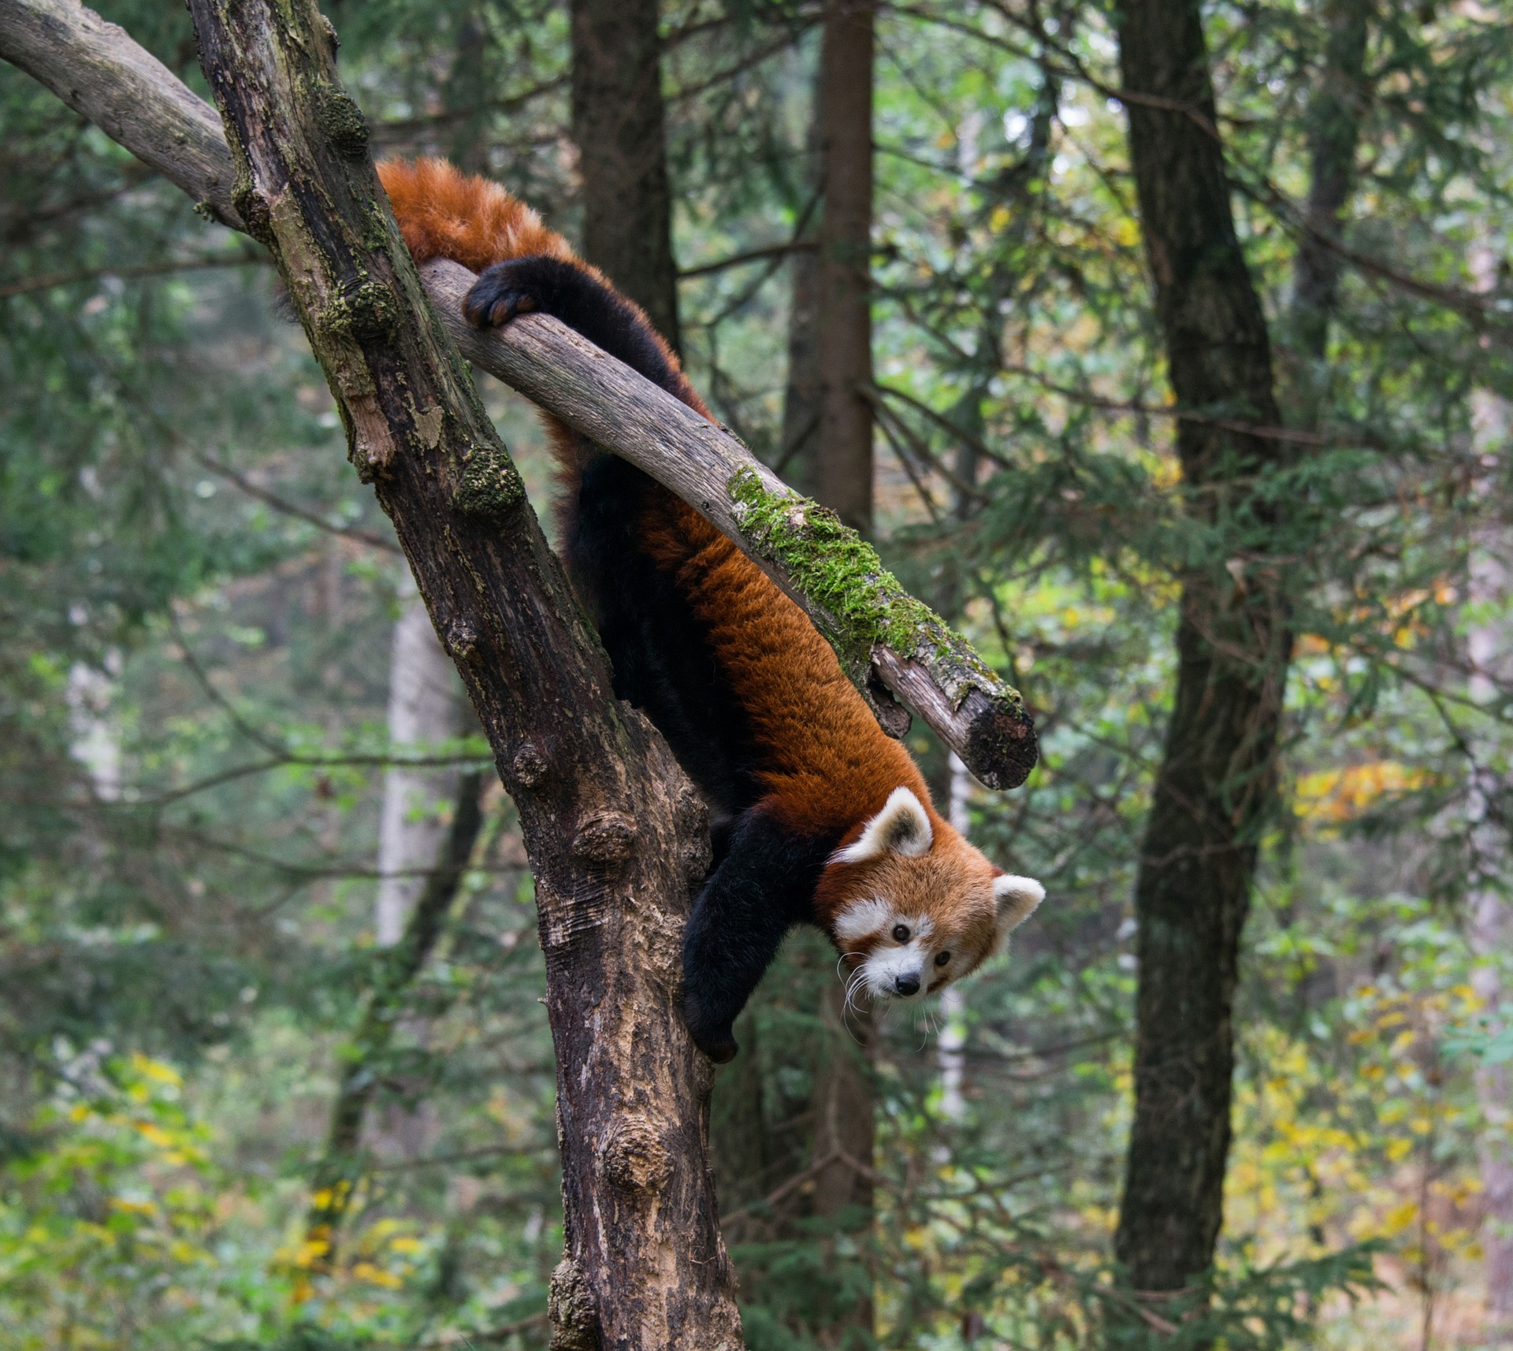 Expanding human populations are encroaching upon a range of habitats, increasing the magnitude of ecosystem modification. Land use change and habitat fragmentation have the largest impact on mammal populations, causing a greater impact globally than hunting. Arboreal mammals with narrowly defined niches and low dispersal capabilities, such as the red panda, are the most susceptible to population declines following habitat disturbance. Thus, quantifying and mapping habitat changes is key for informing conservation efforts when it comes to sensitive specifies such as these. The remote Himalayan range of the red panda makes remote sensing the most viable option for evaluating large-scale habitat change caused by the increasing human population within red panda habitat.

**Figure 1: The arboreal red panda (Aluris Fulgens**). Photo credit

The red panda

The red panda (*alirus fulgens*) is an endangered mammal found in hillside forests with bamboo understory located between 1,000 and 5,000 m. elevation. Red pandas are exacting in their habitat requirements, and prefer undisturbed habitats with over 30% forest and bamboo cover. While they are considered omnivores, red pandas subsist almost exclusively on bamboo, as it makes up 98% of their diet. Red pandas are crepuscular, predominantly solitary, exist at low densities (~ 1 panda per 4 km2), and have been recorded moving a maximum of 30 km away from their place of birth. They have an expected lifespan of 8-10 years in the wild with female red pandas typically giving birth to two cubs every year.

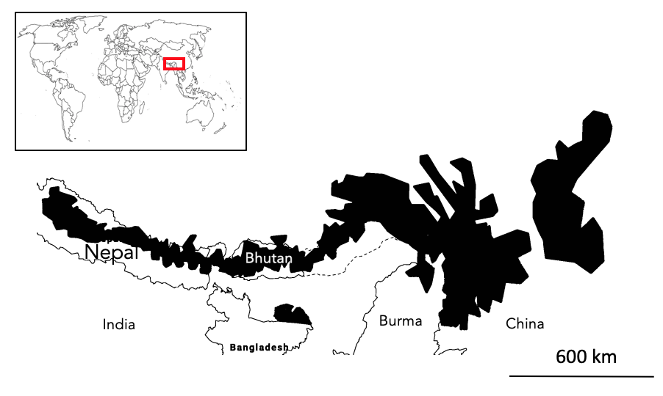The red panda composes its own unique taxonomic family. Two genetically distinct populations of red pandas exist, separated by the Nujiang river valley. Whether these two populations represent two distinct species is still an area of active research. The Meghalaya population is genetically similar to A.fulgens but can occupy more tropical forest at lower elevations. The A.styani subspecies tends to be larger than A.fulgens and has more defined facial markings.

**Figure 2: Distribution of the red panda.** Three isolated population exist, southern slopes population, Meghalaya and, the Eastern Chinese sub species. Original figure by author

Even though this charismatic mammal is now receiving more public attention, conservation efforts for the species lag significantly behind the more famous Giant Panda and other high-altitude species such as the Himalayan musk deer (*Moschus leucogaster*). Many aspects of red panda ecology and distribution still unknown, and research is urgently needed to inform conservation action. It is suspected that the population of red pandas has declined by >50% over the last three generations, raising concerns about species extinction. Precise population trends are unknown due the sparse number of red panda records across its range. Red Pandas are most well documented in Nepal and Sichuan China, yet even here most information comes from indirect signs such as scat and pug marks.

Economic opportunities for people in red panda habitat are limited, and are often based around harvesting natural resources, which tends to damage panda habitat. Habitat loss has been ranked as the the largest threat facing red pandas. Small-scale timber harvesting, and forest clearing for agriculture are the dominant mechanisms for forest loss in red panda habitat. Previously effective conservation actions have involved the establishment of community woodlands and rangers, plus providing more efficient cooking stoves to reduce wood consumption. However, these conservation efforts are very localised, and no range wide species conservation take place. Chance overlap with protected areas has resulted in X amount of habitat being protected, but no protected areas have been created with the primary focus on red panda conservation in mind.

Project Rationale

A range-wide conservation plan is needed to effectively protect red pandas; however, very little information exists on the red panda population as a whole, with almost all red panda studies focused in Nepal or China. As a result, we don’t know the big picture of how red pandas are responding to a changing human landscape. This could lead us to protect the wrong areas or invest conservation resources in inefficient ways. Given the concern about the rate of red panda population decline, there is a particular urgency in assessing the state of this species as a whole.

The tight arboreal niche of red pandas and their susceptibility to habitat disturbance makes evaluating forest change across the range particularly useful for conservation planning. Indeed, the IUCN red panda assessment has identified habitat monitoring as the highest priority research topic for red pandas. Identifying what and where forest cover change is occurring can help inform where the key areas that need protecting are and if panda habitat is being fragmented and isolated. In this dissertation, I use publically available forest cover change datasets, particularly the GFC dataset, to assess what change is occurring across red panda forest habitat and identify where this change is happening. Comparisons will be made between conservation-relevant areas of interest to gauge large scale trends in the pattern of loss. A map of loss has also been created to qualitatively explore finer scale patterns and provide local information for conservation planning.

This is a timely analysis, as both the data on the distribution of red pandas and the tools required to analyse this forest data are only recently available. A MaxEnt distribution model for red pandas was created in 2018 to accurately define the species range. The creation of Cloud-based spatial analysis such as the Google Earth Engine in 2013, provides a free platform to conduct analysis on big spatial data. While this analysis only measures change in a proxy for habitat (forest cover), it should still provide useful information on the extent and location of forest disturbance in red panda habitat. There is precedent for this approach too, as a similar technique using GFC data has been used to evaluate change in key tiger habitat.

.

Box 1. The global forest change dataset

I will write about this more later.

Research questions and hypotheses

RQ1: What change has occurred to forests in red panda habitat?

Due to the assumed significance of this threat from the IUCN and other conservation scientists, I expect a sizable about of forest to have been lost across this entire range. The value of 10% has been chosen arbitrarily to represent a sizable amount of loss. I also expect the rate of forest loss to be increasing as the human population in increasing in red panda habitat. If my predicted amount and rate of forest loss is found, it will provide evidence of the urgency of conservation efforts for the red pandas and could contribute to the reclassification of protection level in China and inform IUCN red list assessments.

H1a: The area of forest in red panda habitat has decreased by >10% from 2000 to 2018 across the entire range.

H10: The area of forest in red panda habitat has decreased by <10% from 2000 to 2018 across the entire range.

H2a: The amount of forest lost each year has increased in red panda habitat from 2000 to 2018 across the entire range.

H20: The amount of forest lost each year has remained the same or decreased in red panda habitat from 2000 to 2018 across the entire range.

RQ2: Where has forest been lost in red panda habitat?

It is expected that the proportion of forest loss will differ across red panda range. Different countries have varying land management strategies and intensity of resource use. For example, Bhutan is expected to show the lowest proportion of forest loss due to its relatively low population whereas china is expected to show the highest forest loss. Across the entire range forest loss is expected to be higher at lower elevations because of the easier access to humans. Areas of high habitat suitability are expected to lose the most forest out of every habitat class as these areas tend to have the best timber and bamboo resources, hence will be targeted more for resource extraction. Areas classified as IUCN Protected Areas will show less forest loss than unprotected areas because of the stronger legal protection in these areas. If these predictions are supported, it will the broadly indicate the most impacted and threatened areas and can help identify possible reasons for forest loss i.e. people driven with elevations, protection, and country populations, and resource driven with the core areas. The full map will show finer forest loss detail and help identify specific areas of substantial forest loss and areas of un disturbed forest.

H3a: Different countries have lost different proportions of forest cover in red panda habitat.

H30: Different countries have lost the same proportion of forest cover in red panda habitat.

H4a: Lower elevations were correlated with more forest loss

H40: There was no correlation between lower elevations and more forest loss, or the correlation was negative.

H5a: Areas of high habitat suitability have seen the highest proportion forest loss.

H50: Areas of high habitat suitability have seen the lowest proportion forest loss or showed no difference.

H6a: Areas classified as an IUCN Protected Area have lost the least proportion forest compared to unprotected areas.

H60: Areas classified as an IUCN Protected Area have lost the highest proportion forest compared to unprotected areas or show no difference in the proportion of lost forest.

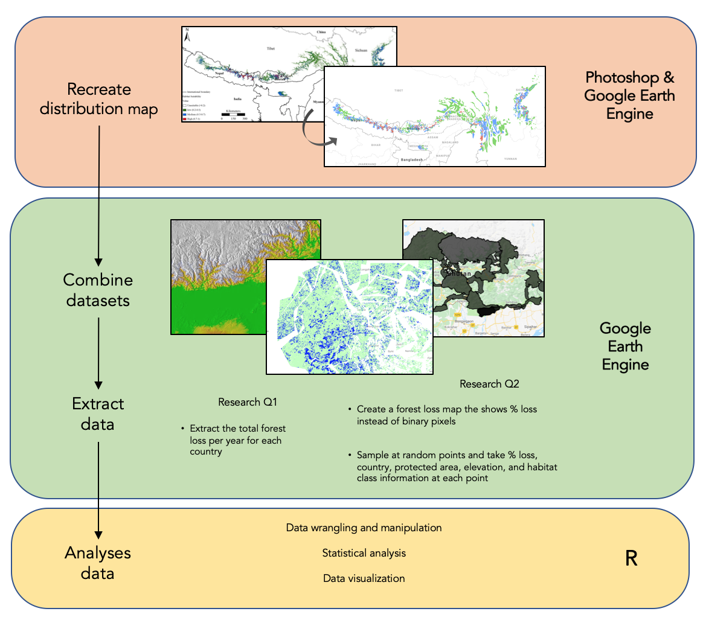2. Methods

**Figure 4: Overview of my methods.**

Defining the study area

All geospatial analysis was conducted within red panda habitat. Red panda habitat was defined as any GFC pixel within the Thapa et al distribution, with over 20% canopy cover in the year 2000. Specifying canopy cover was done to better reflect red panda habitat requirements as they are predominantly found in areas with >25% canopy cover. The Thapa et al distribution was chosen as it is the most accurate and up-to-date model available. GFC data is only available from 2000 to 2018 which has defined the temporal scope of this study.

The distribution map created by Thapa et al was not available as an electronic shapefile, so I recreated the map myself. I used Photoshop to help remap the distribution map onto the base layer of google earth engine, in effect geo-referencing the image by hand using country borders as control points. Polygons were then created on GEE to represent the different habitat classes. Three habitat classes were mapped: Low 20-40%, Moderate, and High suitability. My recreation of the map will have introduced some errors and will have resulted in the miss mapping of some panda habitat. However, visual assessment of my map showed good coverage of predicted habitat.

Analysis in the google earth engine

Datasets

All data used in this dissertation came from pre-existing and publically available datasets (table 1). Each dataset was imported into the google earth engine and had been pre-georeferenced and processed. In order to use the WDPA and Country Polygon datasets in my forest loss map analysis, I had to convert these shapefiles to an image. I did this by clipping a binary land mask to each shape, and creating a new image variable for each country and protected area category. All analysis was conducted using the native scale of the GFC dataset (~30m2).

**Table 1: A description of the datasets used in this dissertation.**

|  |  |  |
| --- | --- | --- |
| Dataset | Provider | Description |
| Hansen V1.6 |  | The image gives a binary layer for loss no loss for 2000 – 2018 (each a separate band) and a cumulative image for the entire range. Forest gain pixels are shown from 2000-2013 |
| Elevation | SRTM Digital Elevation Data 30m |  |
| WDPA: World Database on Protected Areas (polygons) | UN Environment World Conservation Monitoring Centre (UNEP-WCMC) / Protected Planet |  |
| LSIB: Large Scale International Boundary Polygons, Simplified | United States Department of State, Office of the Geographer |  |

Calculating total yearly forest loss

The area of forest lost was calculated using the pixel area function on the loss pixels in the yearly loss bands. A reducer function was then used to sum the loss pixels for each year in each country. The total tree cover at the year 2000, and the amount of gain at 2013 were also extracted in order to calculate the percent loss and associated regrowth. The loss data was exported as a CSV file and imported into R.

GEE script can be found here: <https://code.earthengine.google.com/bd857349150b584ff566631ad960c061>

**The forest loss map**

I transformed the binary Hansen forest loss data into a map where each pixel represents the average forest loss within a 1km2 buffer. I did this for two reasons: i) It is easier to visualise the data and see areas of high forest disturbance and ii) It provides more information on the magnitude of loss at a sample site. A mean neighbourhood circular kernel was used to convolve the image and convert loss/no loss pixels to a % loss measure. The map was then clipped to the bounds of the study area and visualised using a custom style that highlights both areas of low and high forest loss.

To extract data for statistical analysis, I created my own image collection merging the forest loss map, country data, elevation, pa coverage, and habitat class. This gave each pixel information about the amount of loss in the sounding 1 km2 and the value of each independent variable. In order to gauge the variation in forest loss within areas of interest, I used a sample based approach. Using GEE’s random point generator, I sampled 5000 random pixels from my loss map image collection. 5000 was deemed to be the maximum number of samples possible without significant overlapping of sample counts, any more than this would increase double counting of points and make my sample less independent. A table listing the % forest loss and associated independent variables was exported as a CSV file and imported into excel, where it was manipulated into a ‘tidy dataset’. Data was then filtered in R to get rid of samples in areas less than <20% forest and in any overlapping habitat classes caused by error in the recreation of the distribution map.

Statistical analysis

R version alpha = 0.05

All models were planned a priori, and to have biological relevance. No model comparisons have been made as each model is designed for a specific research question. Data distributions and residual fits were visually assessed using qqplots and histograms. A linear model was used for RQ1 and nonparametric analysis was conducted for RQ2 due to the major violations of assumptions of the data (zero inflated and non-normal). Kruskal wails tests were used to compare means. This test was chosen because the distribution of forest loss values was the same shape in every group. Post hoc analysis using the kruskalmc function in pgirmess was done to identify significantly different means whilst also accounting for multiple comparisons, this is analogous to the parametric tukey HSD test.

Statistical approach. A priori model creation, biological relevance.

3. Results

What change has occurred to forests in red panda habitat?

The rate of forest loss in red panda habitat has not significantly increased across the entire range from 2000-2018 (linear model, slope = 0.0014 ± SE 0.0013, Fstatistic = 1.204, DF = 16, adjusted R2= 0.012, P = 0.288). At the country level, India and Burma were the only countries that showed a significant increase in the amount of forest lost between 2000-2018 (Table A1, Appendix). A total forest loss of 1.3% (1753 km2) was found across the entire range. 227 km2 of lost forest had regrown between 2000 - 2013.

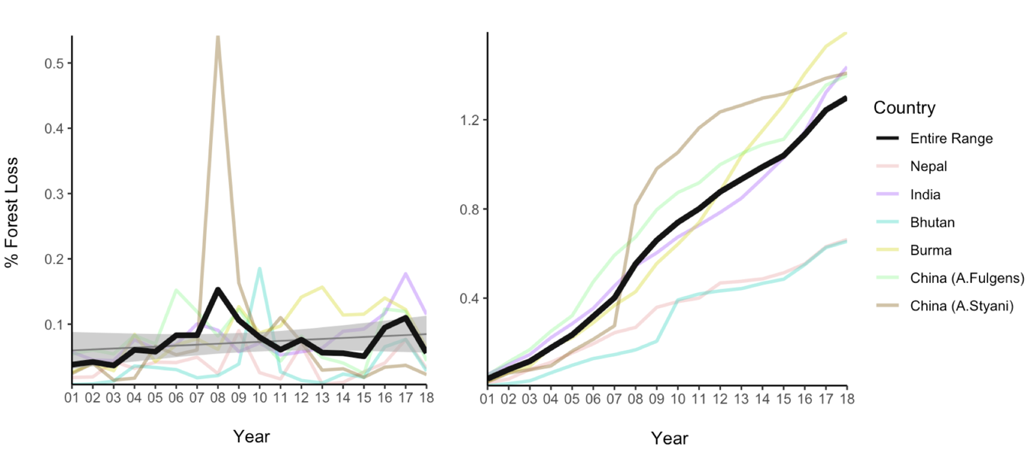

**Figure 5: Total forest cover has changed in red panda habitat from 2000 – 2018.** Left figure shows the yearly % forest loss over the study period for the entire range of the red panda, and each country. The linear model is shown as the smaller black line with the SE shown in gray B) Total area of habitat 134880 km2

Where has forest been lost in red panda habitat?

Habitat loss in red panda habitat is clustered and not uniform across the range. A visual assessment of the location of loss showed that forest loss was usually found close to roads and human settlements.

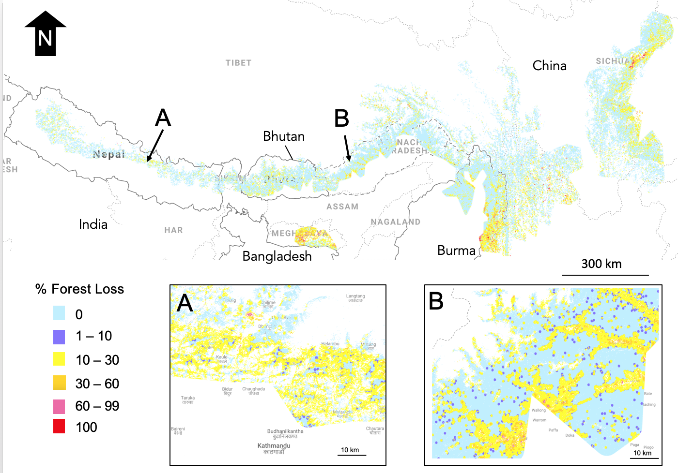**Figure 6: Map of forest loss in Red Panda habitat, with two major bottlenecks (A and B) identified.** Range wide map created with a scale of 100 m, zoom in maps A and B created at the native scale of GFC dataset (~30m).

Different proportions of forest were lost in each country (Kruskal-Wallis, χ2 = 69.256, df = 5 , p-value 1.463e-13). This is in support of H3 with china showing the highest average forest loss and Bhutan and Nepal showing lower loss.

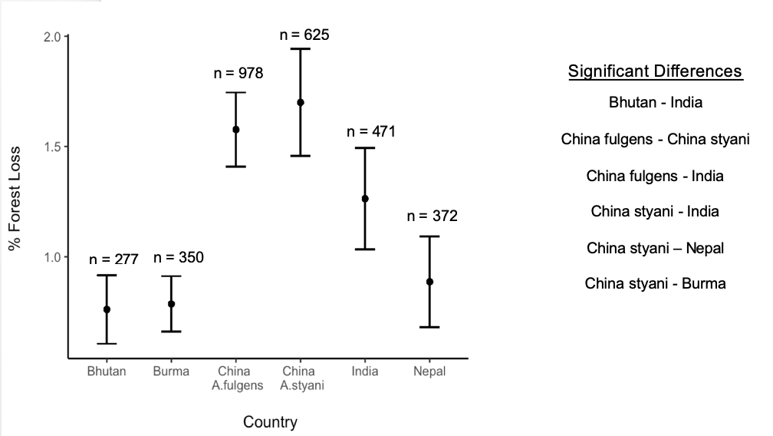

Figure 4

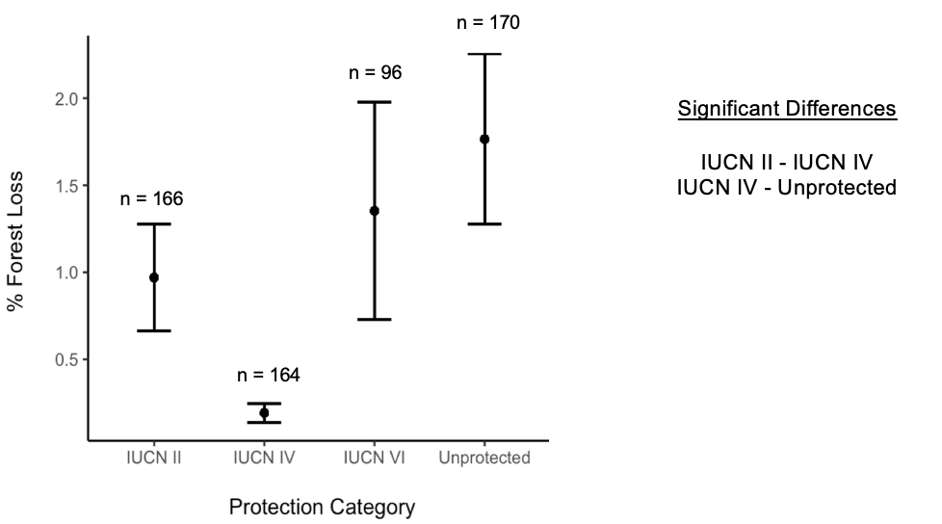Different proportions of forest were lost in areas with different protection (Kruskal-Wallis, χ2 = 16.108, df = 3, p-value 0.001078).

Figure 5

Different proportions of forest were lost in different habitat classes (Kruskal-Wallis, χ2 = 13.753, df = 2 , p-value 0.001). 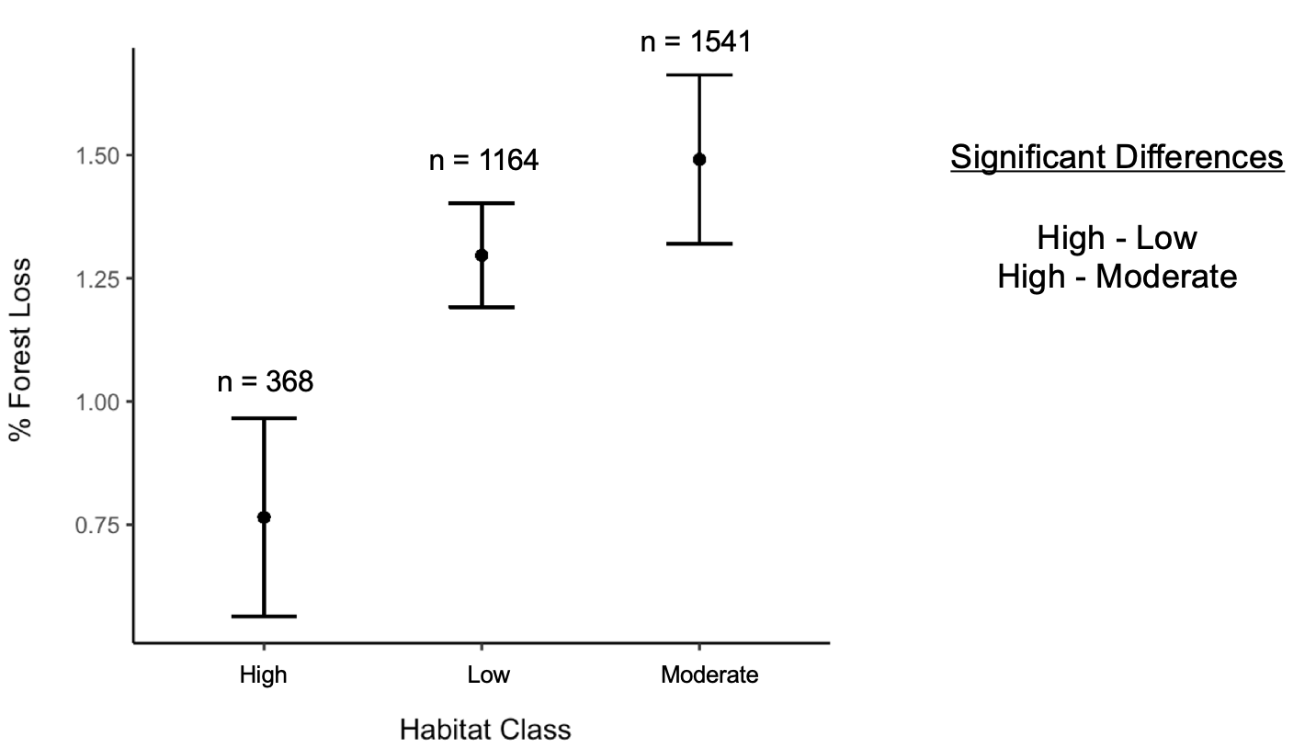

A significant relationship was found between the proportion forest loss and elevation with lower elevations (Spearman Correlation, rho = -0.1506997, n = , p-value < 2.2e-16). The probability of sampling a pixel with forest loss was also higher at lower elevation (Logistic regression, F-statistic = 80.53, Df = 3071, Adjusted R2= 0.02524, p-value = <2e-16).

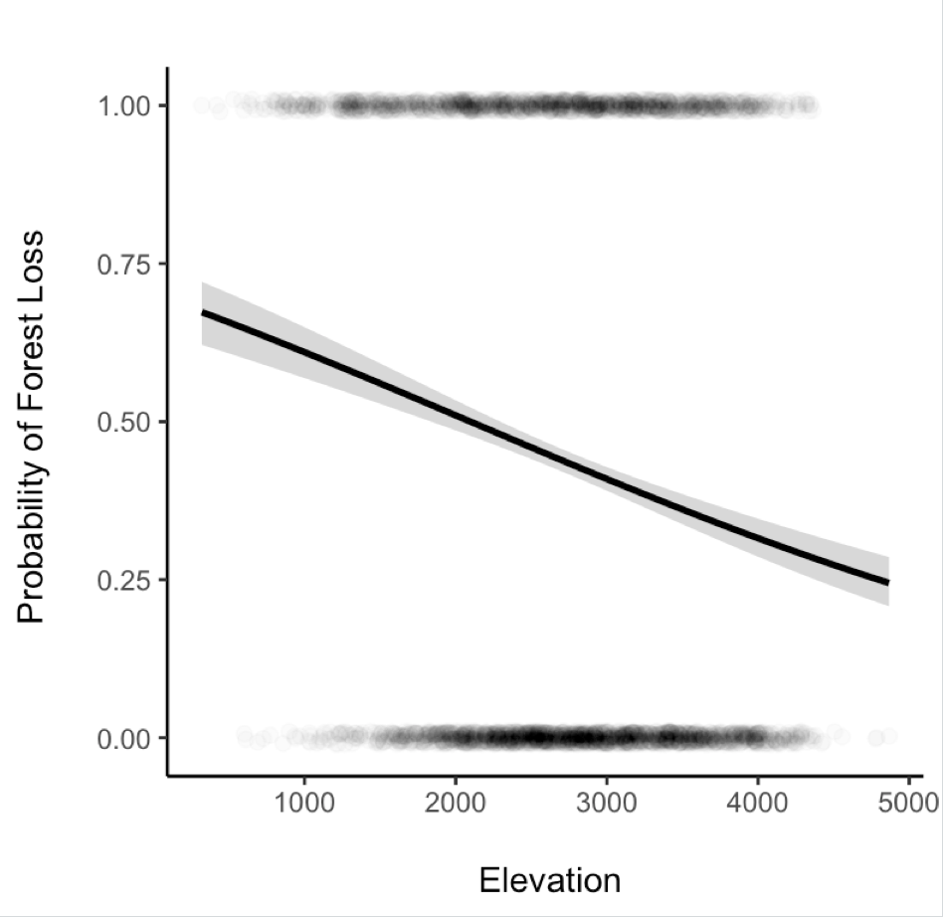

Figure 10

4. Discussion

Red panda habitat has lost significantly less forest cover than expected with only 1.3% of forest being lost between 2000 and 2018 (opposed to the expected 10%). The rate of forest loss is not increasing across the entire range either, resulting in the rejection of both alternate hypotheses for RQ1. However, visual assessment of the forest loss map shows substantial loss in key forest corridors, suggesting it is not how much loss we should be concerned with, but rather where that loss is occurring. The most forest loss was seen in China (Reject H30), unprotected areas (Reject H60), low suitability habitats (Reject H5A) and lower elevation areas (Reject H40). Three main hotspots of loss were identified; Meghalaya, India; southern panda habitat along the Burma and China border; and 50 Km NW of Chengdu, China. My findings suggest that red pandas are at risk of genetic isolation from forest disturbance along the Sothern slopes of the Himalayas. My results also support the suggestion that the Meghalaya area of India is becoming highly degraded and unsuitable for red pandas.

How is Red Panda Habitat changing?

What change has happened to forest in red panda habitat?

The low calculated forest loss was unexpected, but not unreasonable. 7% loss in Tiger paper across south east Asia. Using this adjustment, the real on the ground loss would be 1.5+/-

Rate of forest loss not increasing across the range, but it is India and Burma. This is unexpected as the population in this region is increasing. Temporal autocorrelation is not accounted for would serve to increase rate of slope. Time means more people means more loss. Taking into account possible temporal correlation and imporved methods of detecting small loss, would serve to increase rate of slope. I am confident the rate isn’t increasing across the range but countries are responding differently. Just because the rate isn’t increasing doesn’t mean that a steady amount of loss is good.

Where has loss occurred?

Map, three clusters, association with roads. Loss isn’t homogenous throughout the range.

Burma shows high total loss but low sample based estimate. Large areas of clustered forest loss. Spatial Auto correlation

IUCN unexpected results. Reasons? Much more to this story but it is reassuring that at least IV shows a significantly lower amount of forest loss.

How do these results compare to on the ground studies?

Forest loss vs habitat degradation. Up loss by 30% +/-20%.

Similar loss in Nepal vs the rest of that region.

What needs to be considered when interpreting my results?

PA analysis should look at where loss is occurring. Not just absolute values as these are low.

Map may over estimate habitat as occurrence records are few and far between. Makes the forest loss analysis less specific to rps and may miss more relevant dynamics. Conducting this analysis in areas defined by local experts would produce a more panda relevant map.

IUCN classes run different in different countries

Should look at gain more explicitly.

My methods only quantify loss between 2000 and 2018. Any deforestation before then is not accounted for in my analysis. Visual assessment showed that there were pre-cleared areas, particularly around settlements.

Slightly Unbalanced designs should be ok.

Due to the nature of my data, I had to rely on non-parametric tests in RQ2. Due to the large number of 0 values (no forest loss) across every group, there were many tied ranks. The standard process of averaging tied ranks was done. This resulted in a conservative estimate of significance (lowering the power) and a reduced the type 1 error rate. Kruskal Wallis test also compare the differences in the median value of groups, not the average that figures 6-9 show. If different groups have large difference in the number of tied ranks, the median values can be offset, further lowering the power of the test. A combination of these factors likely resulted in the unusual significant differences, with the apparently similar China A.fulgens and China A.styani being significantly different yet the apparently different Bhutan and China A.fulgens showing no significant difference. If I had more time I would look into models that explicitly deal with non-integer zero inflated data, potentially a quasi-poission mixed effect model or a two part hurdle model. Spatial auto correlation is an issue. I attempted to account for this my adding longitude as a random effect in a mixed model, but due to the major assumption violations, this was not possible.

Conservation implications

Protected areas show signs of working

If pandas are really vulnerable to disturbance, genetic isolation is a large threat. Viable population studies should be considered before a population receives a large investment of conservation resource. Relocation may be necessary in the future to reduce inbreeding depression.

High mountain forest corridors, maintain.

High Suitability habitat is often surrounded my moderate and low. Low habitat classes may act as corridor habitat, this is still important even if core areas are losing less forest

All habitat seems to be connected but there is loss high up the mountains too. Sympatric conservation, pool resources and identify key corridors.

Future work

What else should happen in order to design an effective range wide strategy for red pandas? Need to confirm species occurrence. Camera trapping programme

Quantify fragmentation impacts

Panda density estimates

This will work towards identifying connectivity across the range

Sympatric conservation too with Tiger conservation, Mishmi Tackin and other species of conservation concern. Large overlapping habitat.

Active remote sensing could be used key panda areas to monitor change to the structure of the vegetation and

Forest loss to gain has only been calculated for the entire range. I would explore how gain changed too.

5. Conclusion

This analysis has identified these previously unknown things about red panda habitat and range:

Wide spread disturbance

Potential connection within each three isolated populations, but threat of losing corridors.

There are caveats to some of the inferences made, but broadly this method has worked well to quickly assess the state of forest cover change across the entire range of red panda habitat.

A range wide conservation plan for red pandas would need to consider:

Genetic isolation from high disturbance bottlenecks in corridors. Ensure corridors are in place, especially in high altitudes.

Ensure the viability of population before conservation resources are spent

The type of protected area that works

Shift awareness raising message from the amount of forest loss, to focus more on the locaition of loss.

6. References

UNEP-WCMC and IUCN (year), Protected Planet: The World Database on Protected Areas (WDPA) [On-line], [insert month/year of the version used], Cambridge, UK: UNEP-WCMC and IUCN Available at: www.protectedplanet.net.

Farr, T.G., Rosen, P.A., Caro, E., Crippen, R., Duren, R., Hensley, S., Kobrick, M., Paller, M., Rodriguez, E., Roth, L., Seal, D., Shaffer, S., Shimada, J., Umland, J., Werner, M., Oskin, M., Burbank, D., and Alsdorf, D.E., 2007, The shuttle radar topography mission: Reviews of Geophysics, v. 45, no. 2, RG2004, at <https://doi.org/10.1029/2005RG000183>.

7. Appendices

Country level breakdown of forest loss rate

India = linear model, slope = 0.004089 ± SE 0.001146, F1,16 = 12.74, P = 0.002563, DF = 16, adjusted R2= 0.4084

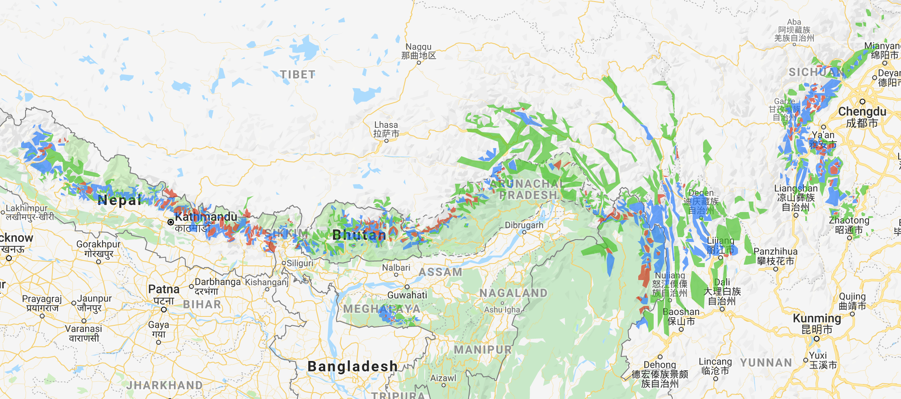

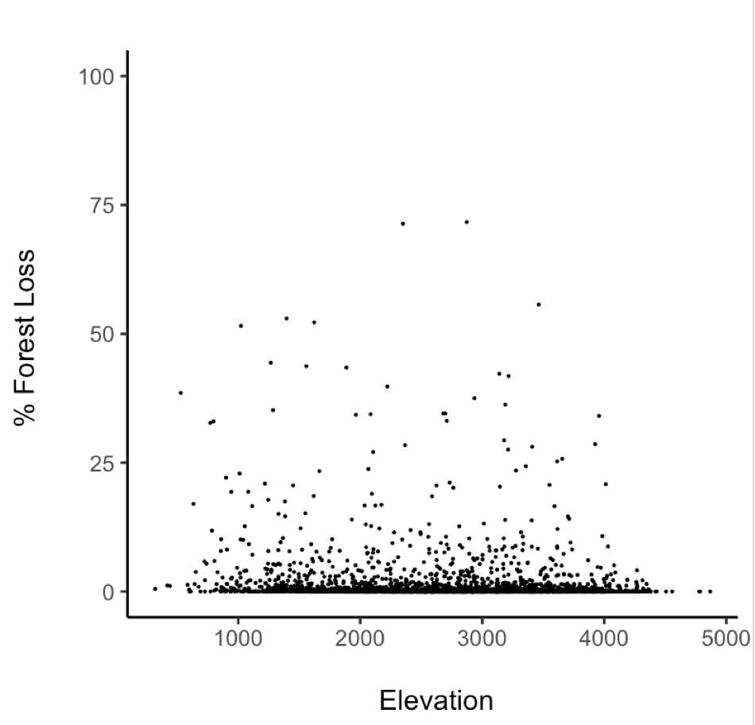

8. Text junk yard

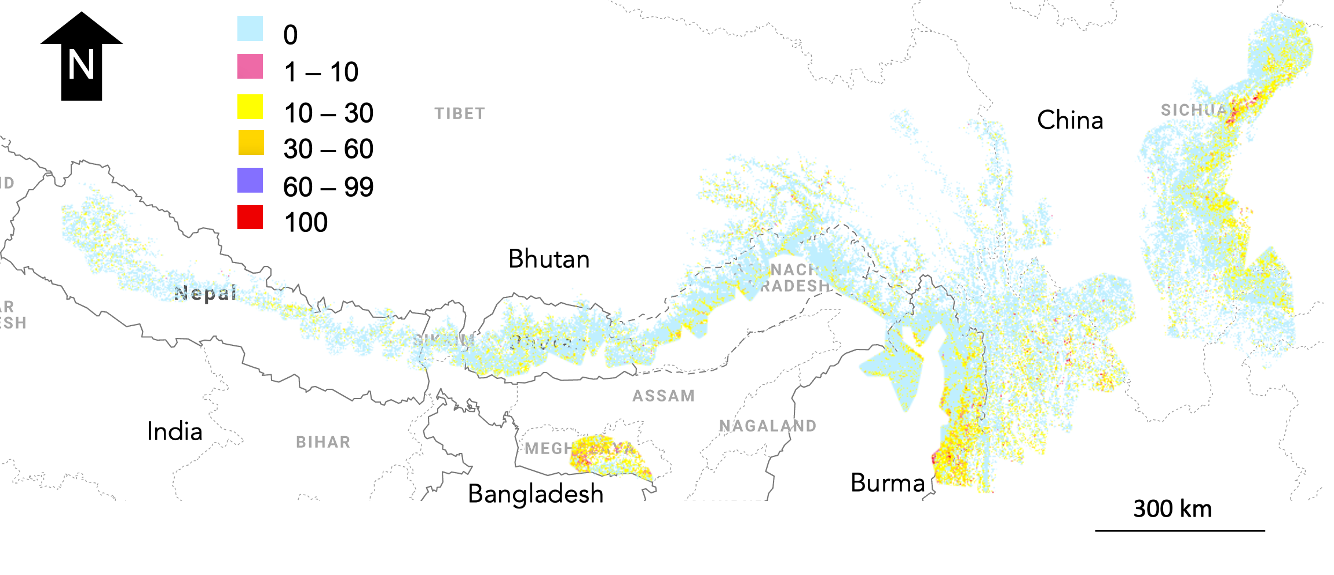The IUCN small carnivore group has identified habitat monitoring as the highest priority research topic for red pandas.